1. Go to databricks and create two more notebooks to print the satements that which process in going on

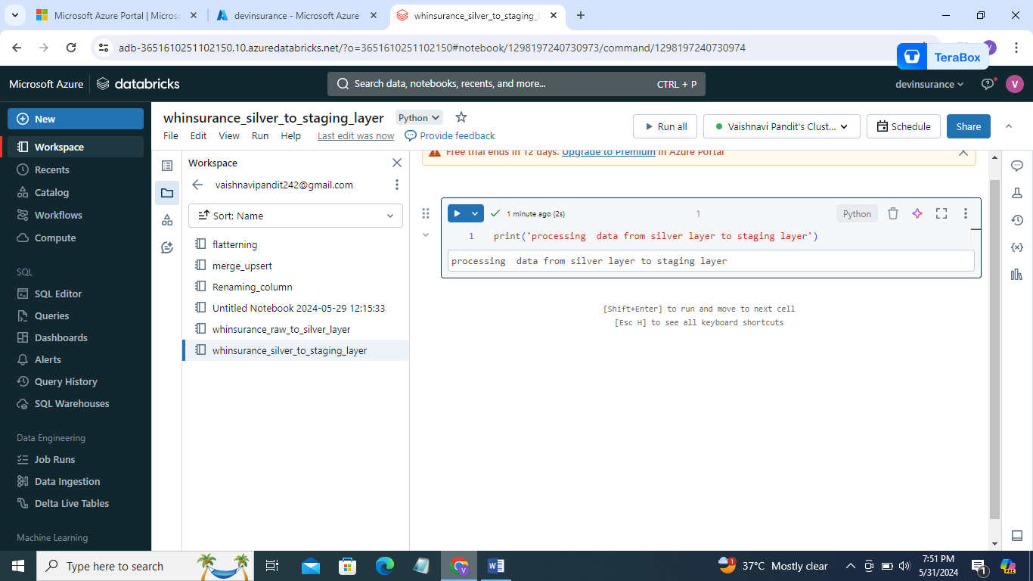

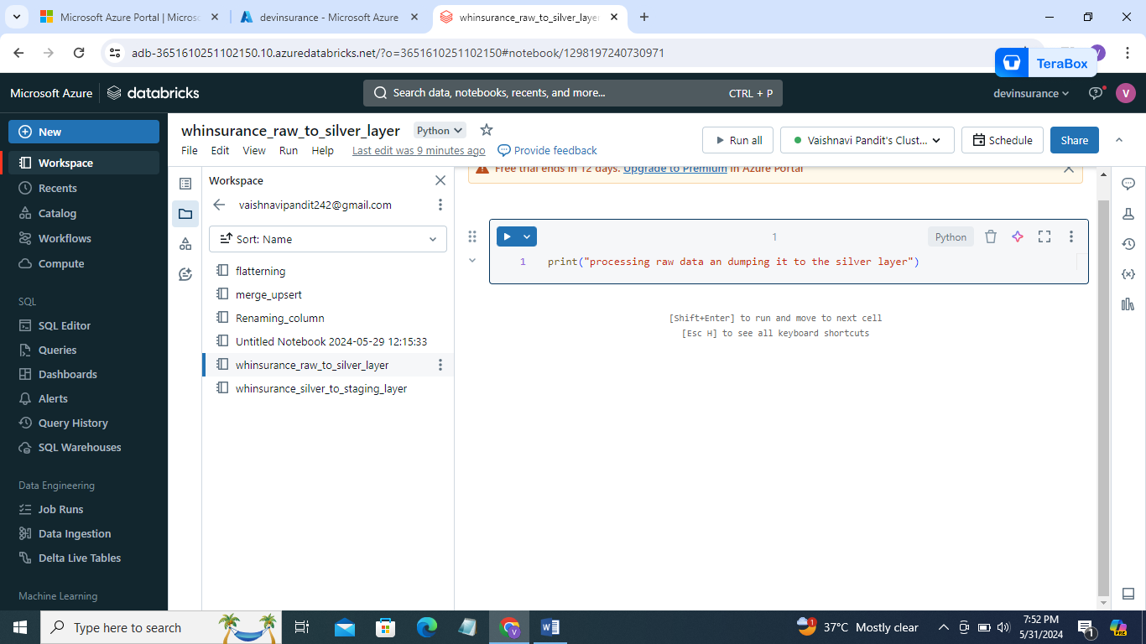

1. Now add triggers so that these all notebooks run after evry 30 mins

Go to workflows

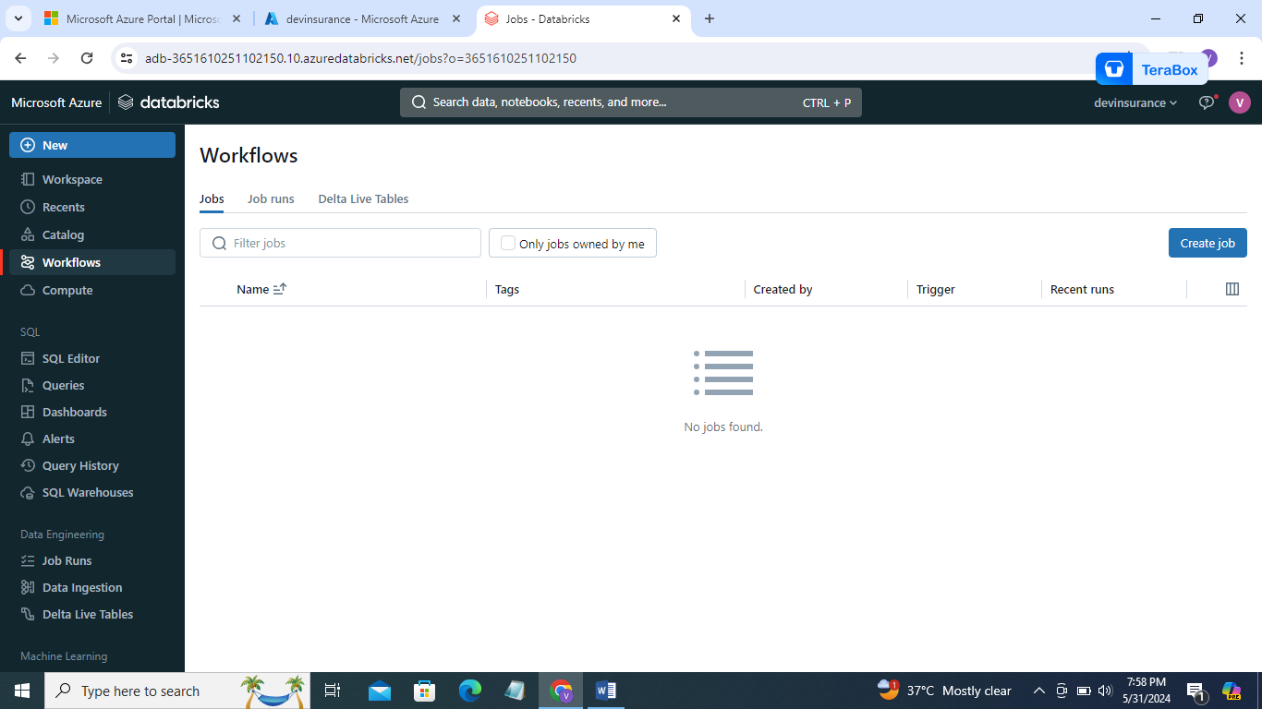

1. Go to create job

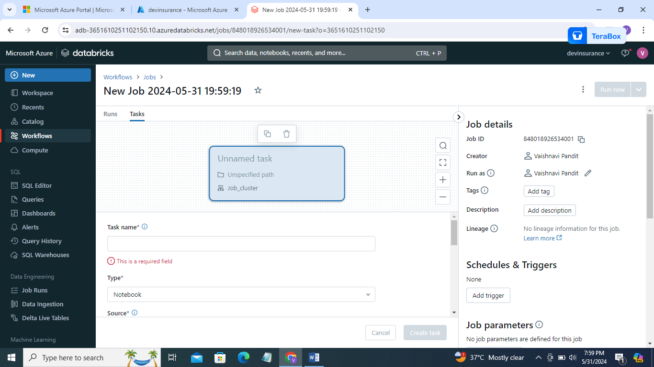

1. Go to unnamed task add task name add path

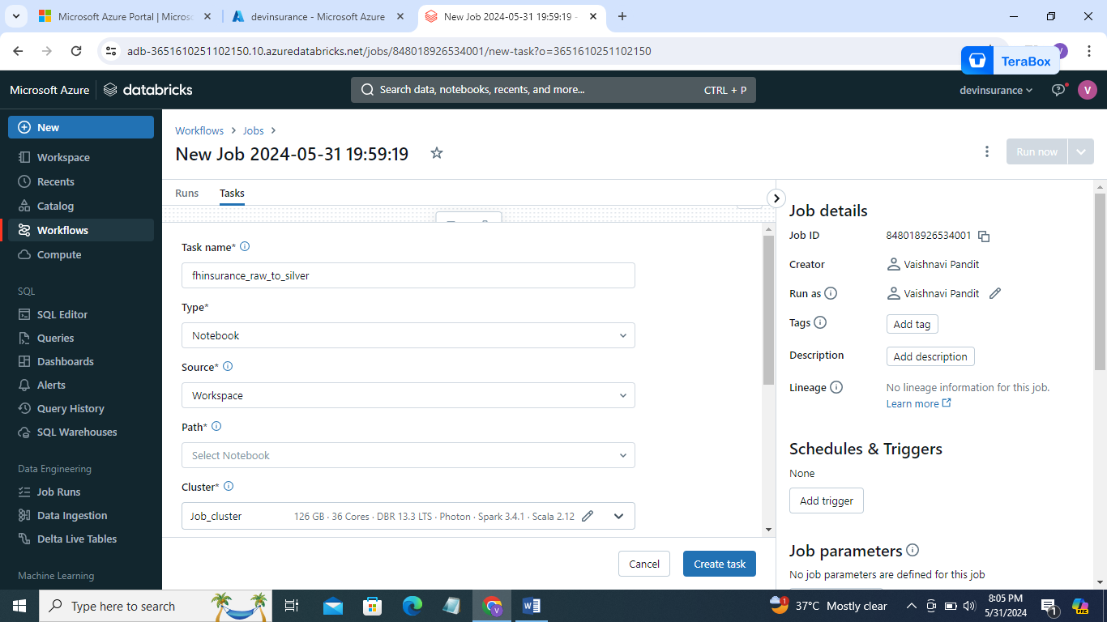

1. Add path click on path-> add path of merge upsert

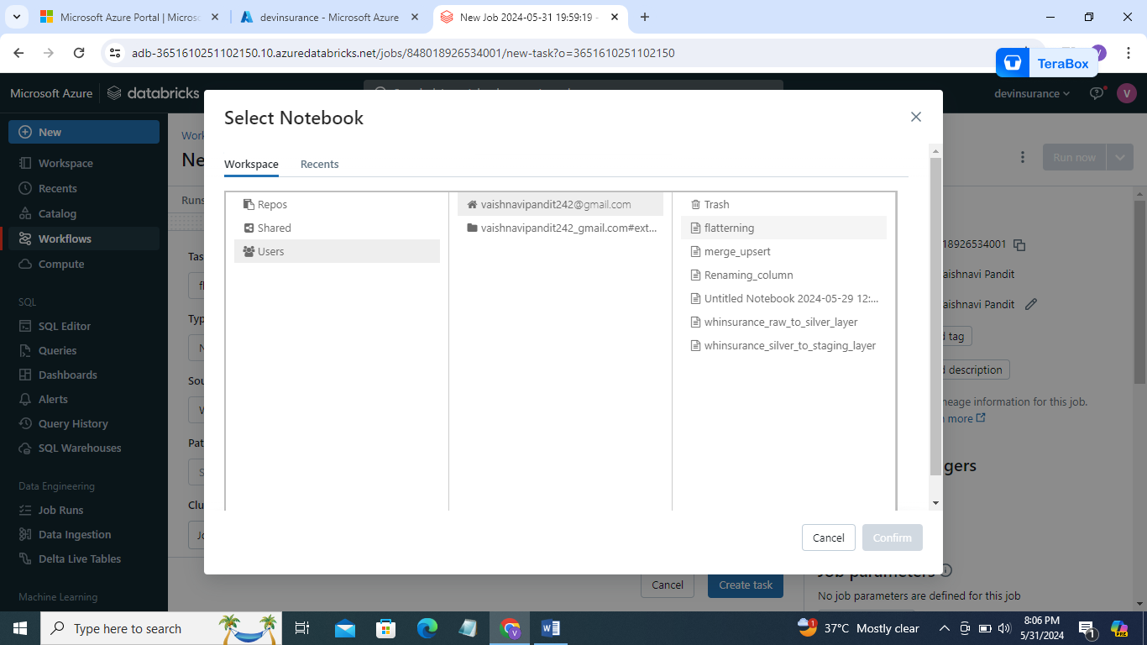

1. Create task

Now click on add tasks

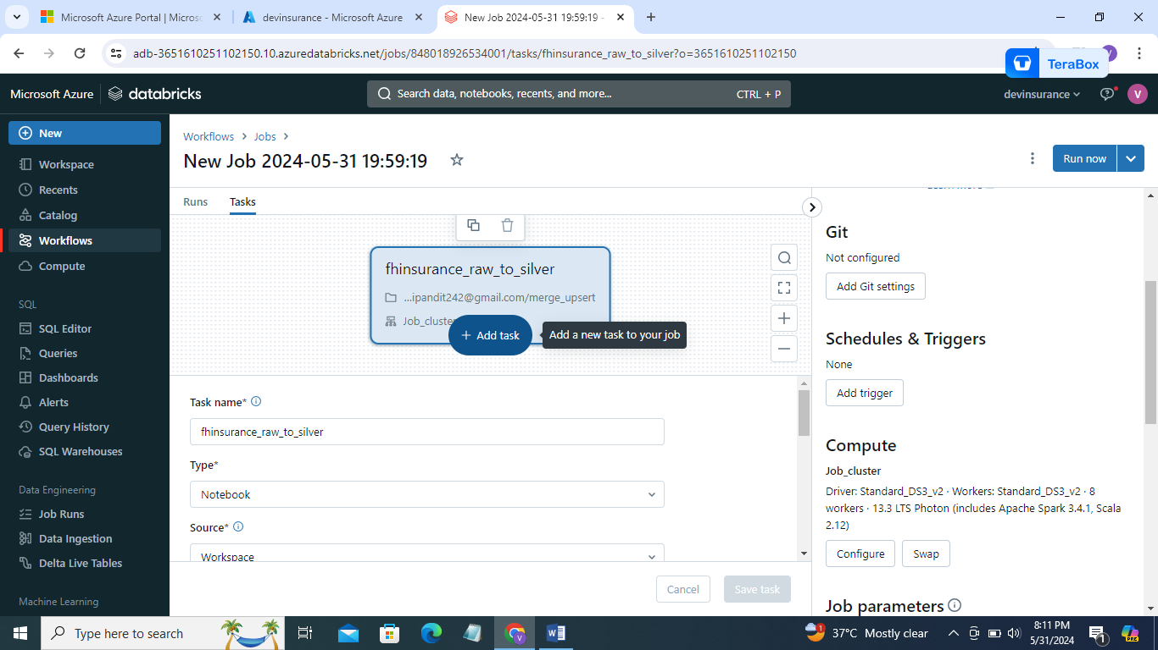

1. And add task for renaming notebook so that it will run after the first notebook merge upsert is run
2. 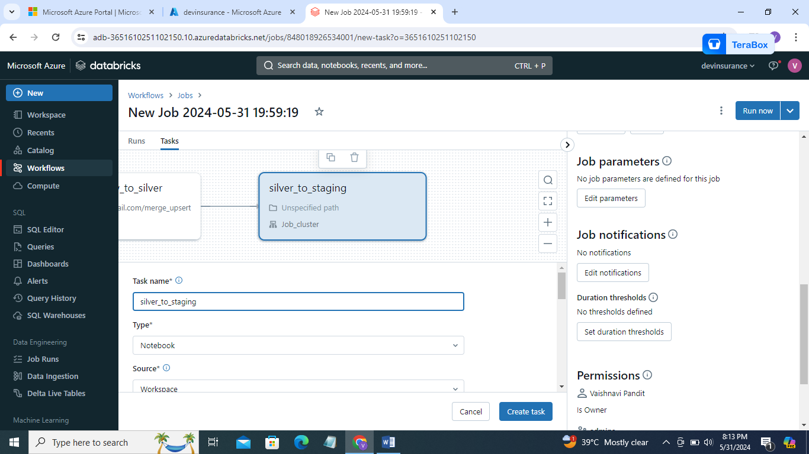
3. 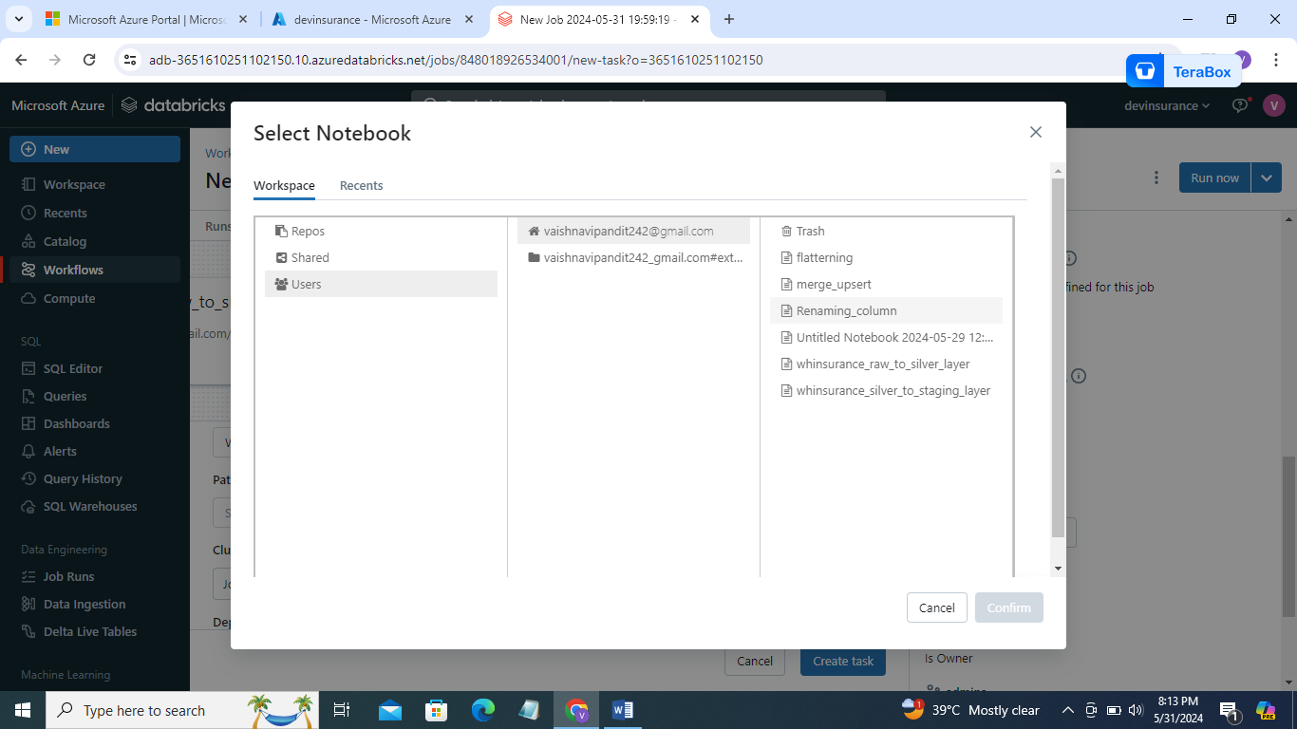
4. Go to add task add one more task for whinsurance_raw_to_silver

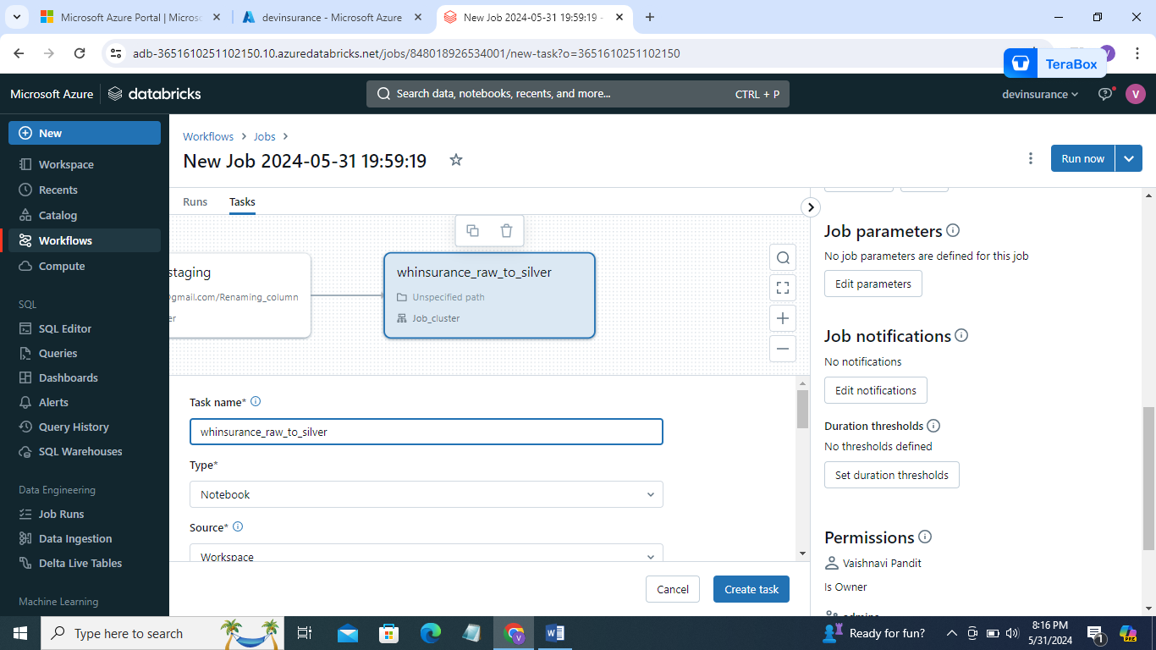

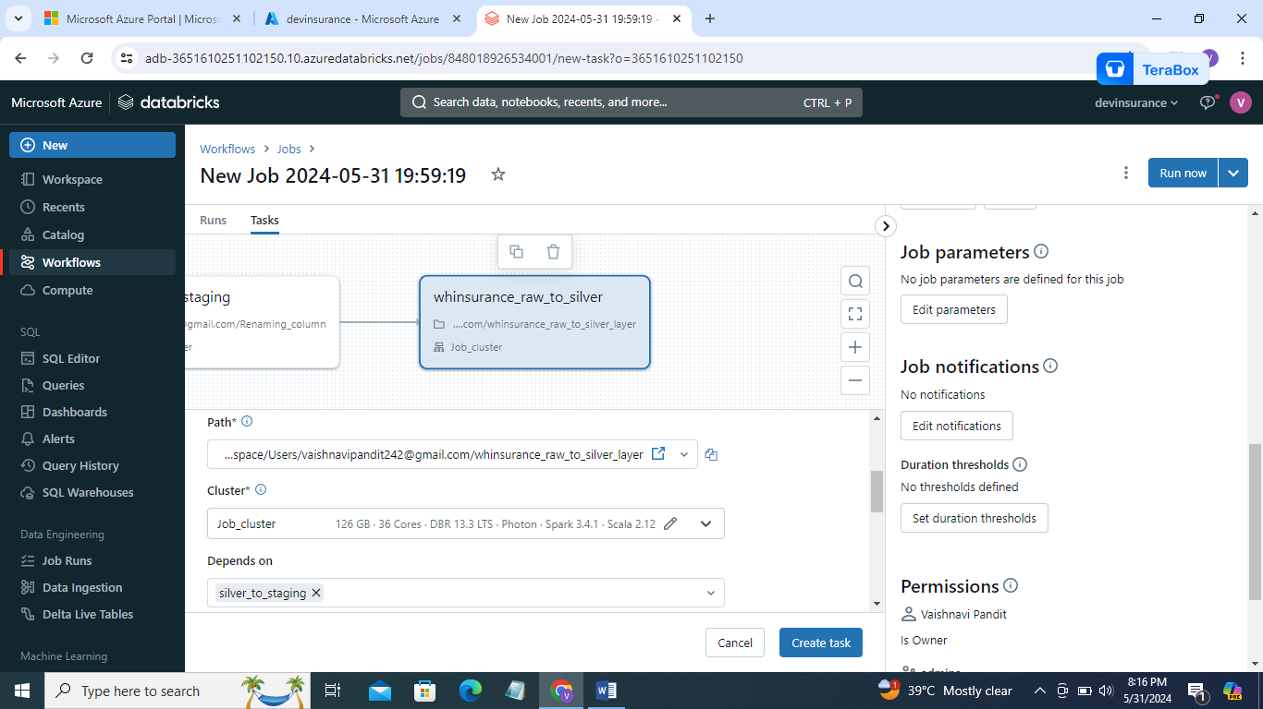

1. now go to depends on and remove dependencies

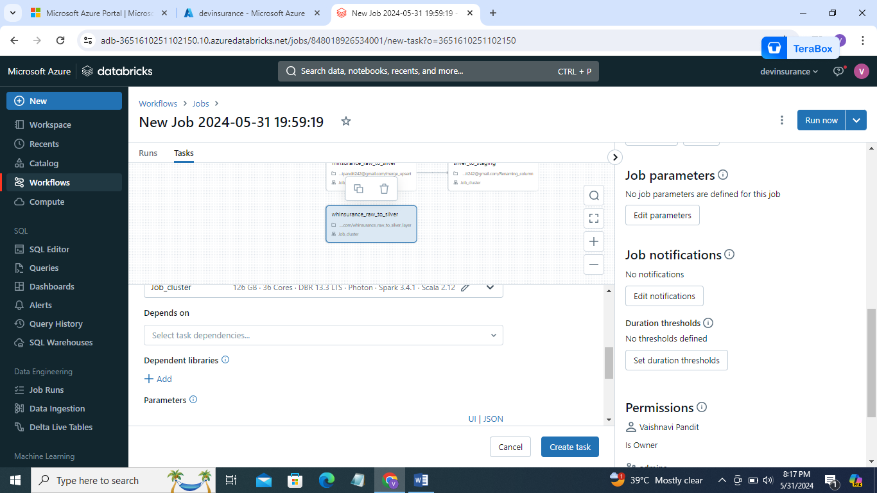

1. create task
2. now create one more task for whinsurance_silver_to_staging_layer

go to add tasks

select dependency whinsurance_raw_to_silver_layer

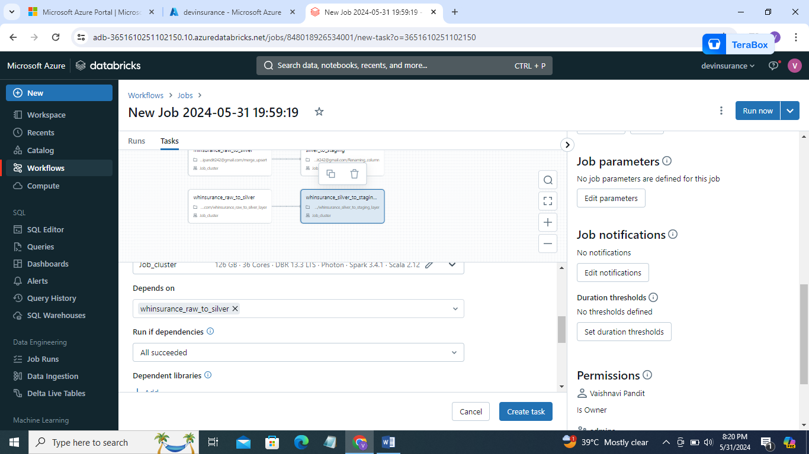

1. dependencies will look like this

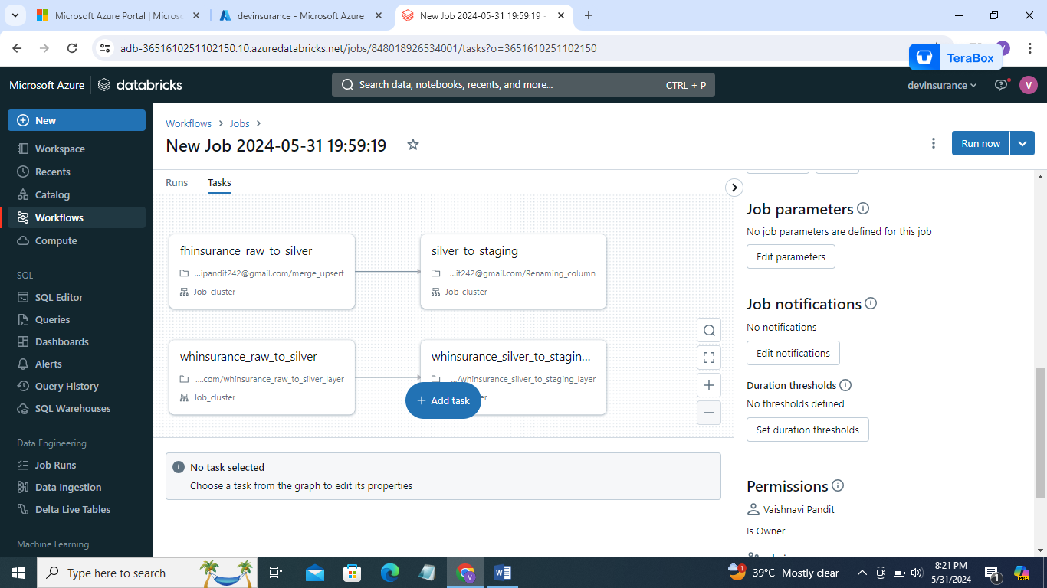

1. now go to->workflow->jobs->then go to schedule->add triggers

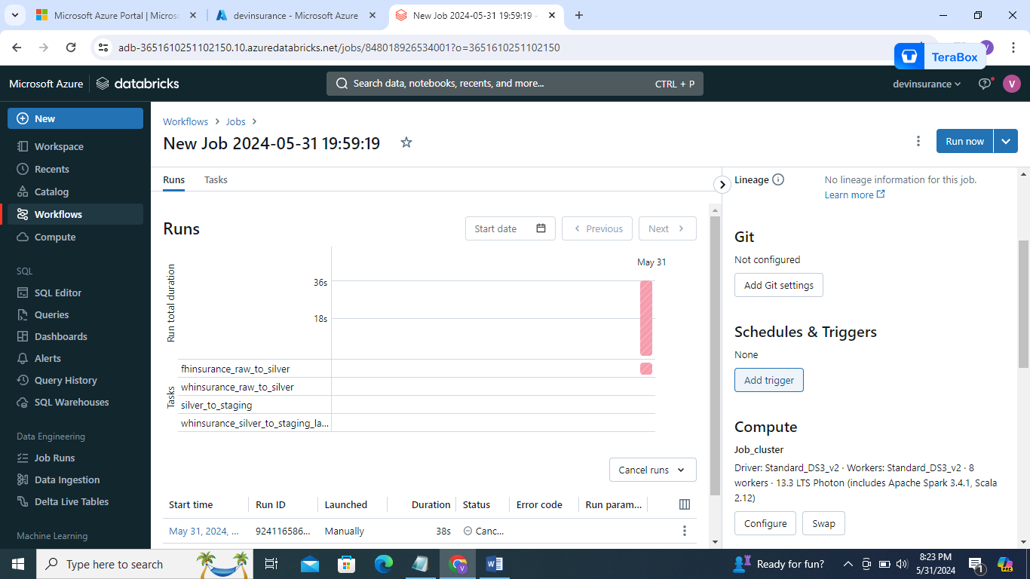

1. trigger type->scheduled->every day ->and select minutes and past 1hor 1 min->past 1hour 1min means trigger will run at 9.01->9.31->10.01->10.31

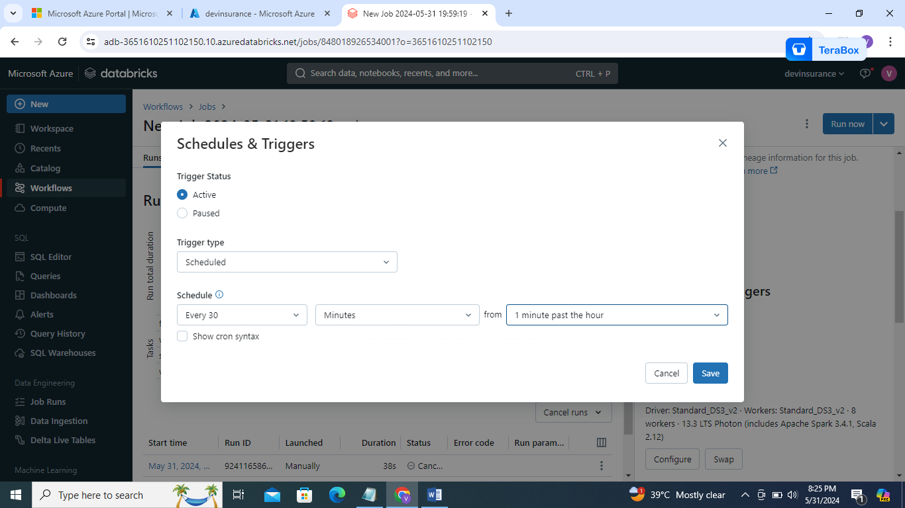

1. save